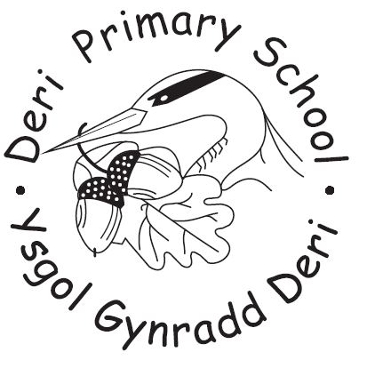
DERI PRIMARY SCHOOL
GOVERNING BODY ANNUAL REPORT TO PARENTS
FOR THE ACADEMIC YEAR 2015 - 2016
ISSUED December 2016

Dear Parents,

Another really productive year has passed at Deri Primary School and I am pleased to introduce this Annual Report to Parents from the Governing Body.

Our new Headteacher, Paul Hamer took up his post after half term 2015 and has just completed a full year with us. Mr Hamer has been dedicated and committed to building on our school success both in school, in the community and further afield. The Governing Body would like to express their thanks for all his hard work and effort in leading our school. We would also like to thank the entire school staff for their continued commitment, dedication and hard work and for being so supportive. Last but by no means least we want to thank the Friends of Deri Primary who continue to support the school both socially and financially and to all parents, carers and families who support our school in so many ways.
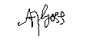

Annette Goss – Chair of Governors

Notification

This is a report of the steps taken by the Governing Body in discharge of its functions during the last academic year September 2015 – July 2016. The Governing Body is no longer required to hold an annual meeting with parents to discuss the report. Parents can request up to three meetings per year with the Governing Body via a petition – details can be found in the school Standards and Organisation (Wales) 2013 Act.

2. Members of the Governing Body

Clerk to Governors: Ms Theresa Van drunen

Governor Support & Development Officer
Education Achievement Service for South East Wales
T. 01443 863155
www.sewaleseas.org.uk/eas
Chairperson of Governors: Mrs A. Goss
1 Bargoed Terrace
Deri
Bargoed
Caerphilly
CF81 9JA
Tel No: 07939 938167

Headteacher: Mr P. Hamer

County Council Representation (2) Appointed by L.E.A.
CB Cllr. D.T. Hardacre 20/9/2016
Cllr Mrs G Matthews 20/9/2016
Mrs Hayley Bowen 9/2/2020

Co-opted/Community Representative (3)
Mrs A Walker 12/12/2018
Mr John Vincent 14/11/2019
Mrs Annette Goss 11/3/2020

Minor Authority Representative (1)
Mrs Claire McLaughlan 24/2/2019

Teacher Governor (1) – Elected by the teachers
Mrs A. James 18/09/2017

Staff Governors (2) – Elected by non-teaching staff

Mrs K Hughes-Jones 21/11/2016

Parent Governors (4) – Elected by the parents

Mr Jason Banks 21/10/2016

If you are interested in becoming a Governor, please contact the Head teacher.
No travelling or subsistence expenses have been claimed by any member of the Governing Body during the year.

- Attendance Sept 2015 – July 2016

 | Sessions | %

Attendances | 27685 | 93.87
Authorised absences | 1471 | 4.99
Unauthorised absences | 338 | 1.15
Possible Attendance | 29494

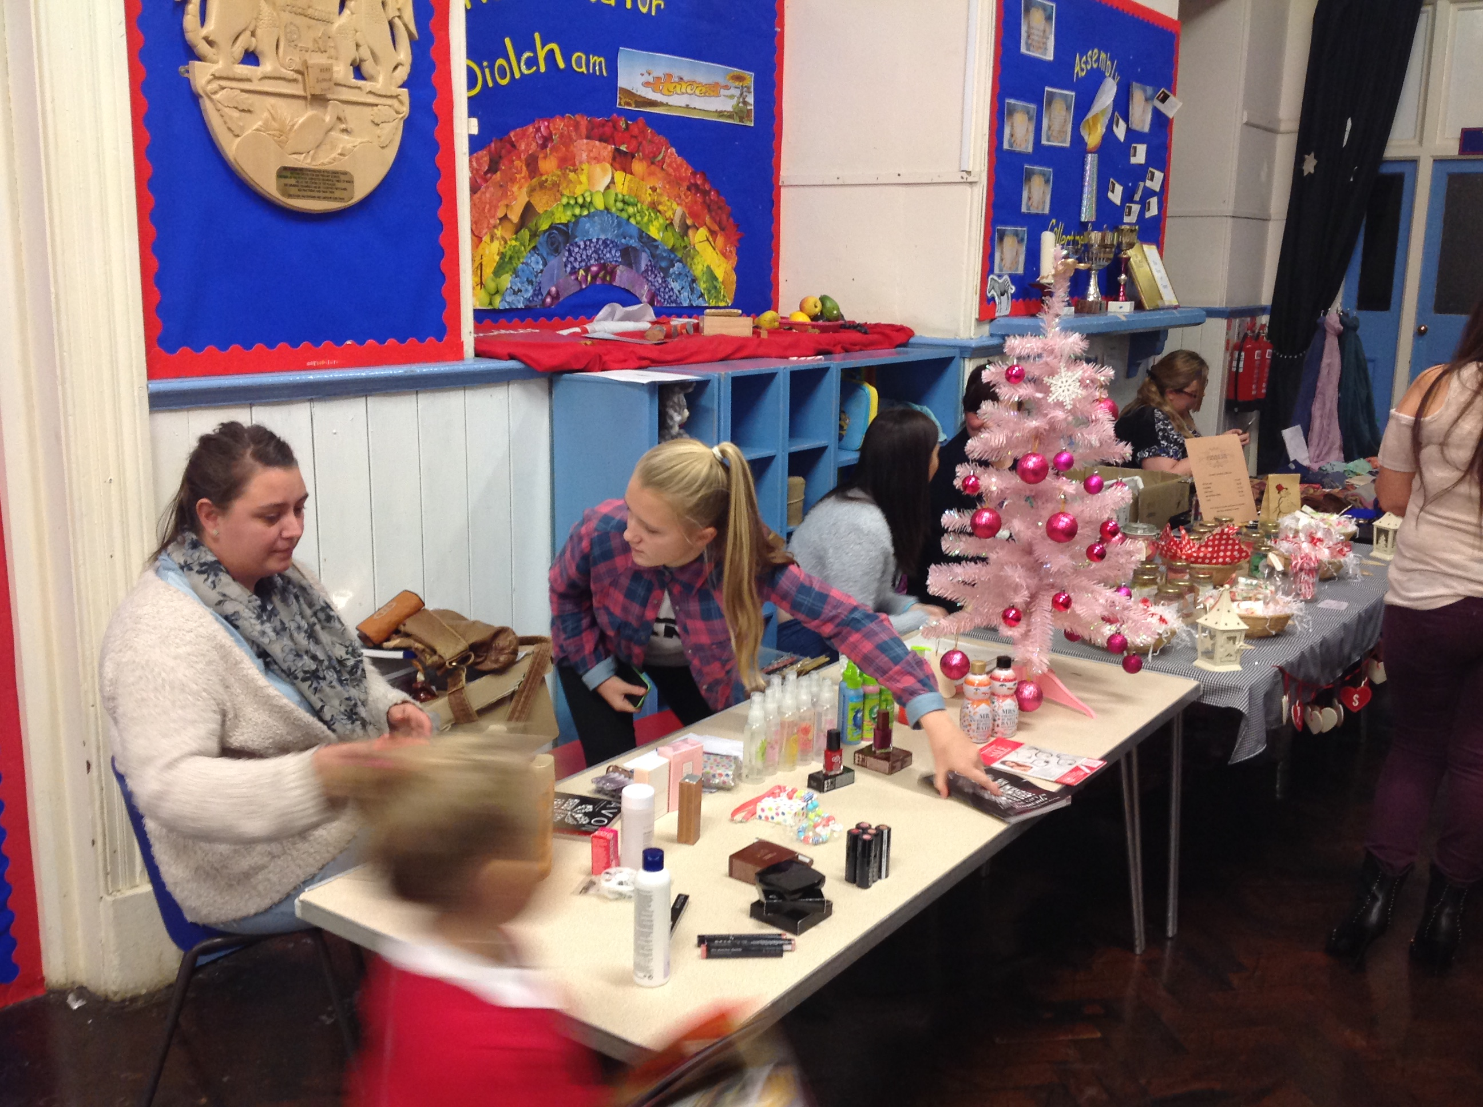
Including
Approved Educational Activity | 463 | 1.57
Lates before reg closed | 89 | 0.30
Lates after reg closed | 18 | 0.06
Unexplained absences | 0 | 0.00

Targets set for attendance: Local Authority 15/16 - 95.0%

School 13/14 - 93.2%
School 14/15 - 94.9%
School 15/16 - 95.0%

- Action taken to develop or strengthen links with the community

- Walking Bus – weekly - Grand opening of safer pathway – 16.5.14.
- Work experience pupils from Heolddu Comprehensive.
- School Council Fete – families invited.
- Pamper evening – village invited.
- PC Penrose Community Police Liaison – year cycle of activities.
- PC Lewis – Neighbourhood Watch Competition.
- St. David’s day photographs in Rhymney Valley Express.
- Deri Ni project and I beacon launch – school & Deri History Society.
- Eco Committee – community litter picking.
- Police and fire Crew at Summer Fete
- Deri Ducklings for under 3’s – stay & play session.
- Harvest/Christmas/Easter Services in Ysgwyddgwyn & St. Peter’s Church.
- FOS Discos in Rugby Club.
- All classes – Tesco visits – “Farm to Food”.
- Regular Deri Library visits.
- Use of amenities e.g. park, cycle track, shop etc.
- Class Assemblies in Summer Term
- Community Learning Sessions
- Rags To Riches and Battery Recycling

- Targets set for Pupil Performance September 2015-16 (all pupils including SRB pupils)

 | Language | Maths | PSD/Science
Foundation Phase | 69% | 77% | 85%
Key Stage 2 | 100% | 100% | 100%

- Details of arrangements for pupils to participate in sport and extra-curricular activities

- science transition Years 5/6
- Upbeat music for Years 4/5/6
- Drama Transition for year5/6
- Cross Country Tournament (KS2)
- Warburtons Workshop for years 2 to 6 (day)
- PC Penrose, Cyber bullying and Wings to Fly for Years 4/5/6 and Year 6
- Alun Morgan to Judge Heritage History Competition.
- Music and drama transition for years4/5/6
- Music and drama transition
- FODs sponsored walk
- Dosbarth Pump visit to Green Meadow farm
- Gymnastics sessions for D5 at VGA (Oakdale)
- Swimming for KS 2 (three week block).
- Football tournament at Ystrad Mynach
- Recycling talk from Dave Shakeland for KS 2
- SAP group started (8 sessions)
- Activities for Year rec to 6 at Cwm Darren Park (Pond dipping and mini-beast hunting).
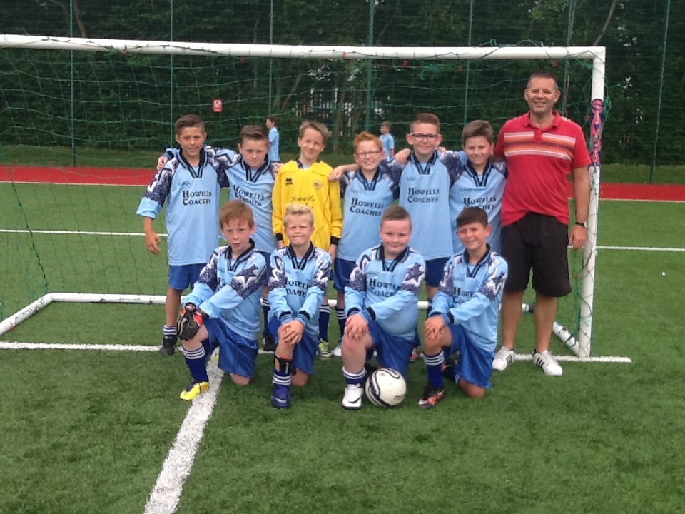
- Pupil transition to comprehensive
- Sports day with sponsored fruit and water from Morrisons.
- Whole school trip to Folly Farm

- Action taken to implement and review school strategies and policies

Revision and amendments made to school strategies and policies has been ongoing and reported to parents in newsletters/via the texting service.

Autumn Term 2017
- Term starts Monday 4th September 2017
- Half term starts Monday 28 October 2017
- Half term ends Friday 3rd Novemebr 2017
- Term ends Friday 22nd December 2017

Spring Term 2018
- Term starts Monday 8th January 2018
- Half term starts Monday 19th February 2018
- Half term ends Friday 23rd February 2018
- Term ends Friday 30th April 2018

Summer Term 2018
- Term starts Monday 16th April 2018
- Half term starts Monday 28th May 2018
- Half term ends Friday 1st June 2018
- Term ends Tuesday 24th July 2018

- Term dates & session times

Autumn Term 2016
- Term starts Thursday 1 September 2016
- Half term starts Monday 24 October 2016
- Half term ends Friday 28 October 2016
- Term ends Friday 16 December 2016

Spring Term 2017
- Term starts Tuesday 3 January 2017
- Half term starts Monday 20 February 2017
- Half term ends Friday 24 February 2017
- Term ends Friday 7 April 2017

Summer Term 2017
- Term starts Monday 24 April 2017
- Half term starts Monday 29 May 2017
- Half term ends Friday 2 June 2017
- Term ends Friday 21 July 2017

Five Additional teacher training days are to be taken throughout the year at the discretion of the school and school governors. School will inform you of these through newsletters/texting service.

- Summary of changes to school prospectus since publication


Parents are made aware of all changes through newsletters/texting service.

- Curriculum Statement

At Deri Primary School, we aim to provide each child with opportunities to develop socially, emotionally, physically, spiritually and intellectually. It is our aim to provide a broad, balanced exciting and stimulating curriculum, providing the highest quality teaching and learning experiences for all children. We aim to meet the statutory requirements of Foundation Phase Framework and the National Curriculum and, more importantly, ensure that we do what is right for the learners in our care.

The school endeavours to identify as early as possible children requiring SEN support and implements the code of practice in identifying and assessing special education needs.

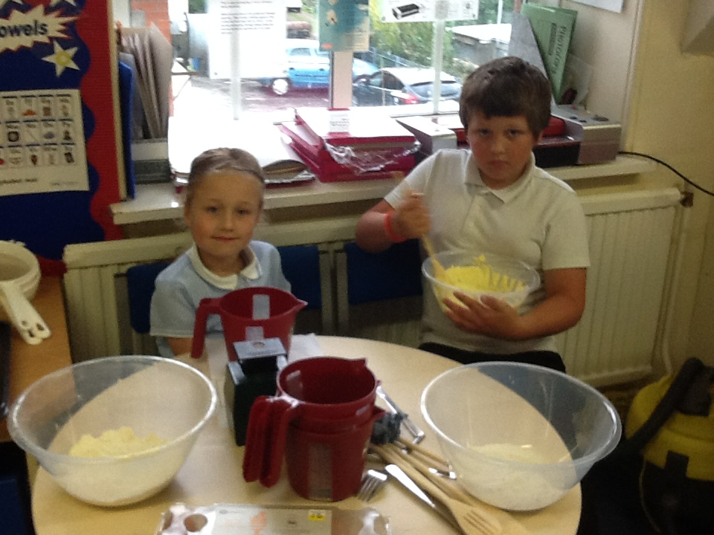
The school has a special needs policy which is available upon request. The school is in regular contact with the LEA through various inclusion services, e.g. psychology behaviour support. These services allow us to discuss problems encountered with individual children, and enable us to develop individual learning programmes.

- Language category of the school

Deri Primary is an English medium school.

- Use of Welsh Language

At Deri Primary School, we aim to create an atmosphere within the school
conducive to the learning of Welsh, we give the language a prominent place around
the school and by using the Welsh language in assemblies, concerts, projects and
whenever possible during the school day. Structured Welsh lessons develop skills in
oracy, reading and writing.

- Toilet Facilities and cleaning arrangements

Deri Primary School has three separate toilet areas for pupils. One for the Nursery/Reception (mixed) and Y1-Y6 girls, one for the Y1-Y6 boys and for one pupils who are disabled or who need assistance with toileting.

The school employs a full time caretaker/cleaner who cleans the facilities daily.

The Local Authority undertakes regular ‘spot checks’ to ensure that the toilet facilities meet regulations.

- Healthy Eating and Drinking

The school complies with the Healthy Eating in Schools Measure 2009 and the Healthy Eating in Schools Regulations 2013. School lunch provision is provided by the in-house provider, Caerphilly Catering who are fully compliant.

Deri Primary has achieved Phase 5 of the Healthy School Scheme, and is working towards Phase 6 and actively promotes healthy eating and drinking e.g. healthy snacks at lunchtime, stickers for healthy lunchboxes. We encourage pupils to bring in water bottles daily and drinking water is available. The school takes reasonable steps to ensure that every pupil who is entitled to receive free schools lunches and free school milk receives them.
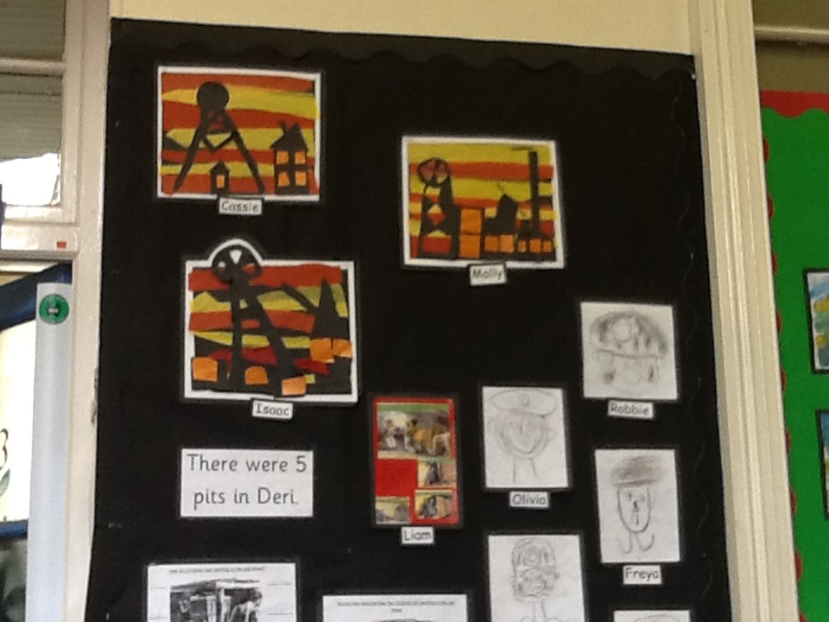

This report uses data for 2016 for LA and Wales comparative information
School comparative information: Foundation Phase Outcomes 2016 with benchmarking
Percentage of boys, girls, and pupils achieving at least the expected outcome (Outcome 5+):
 | Boys |  |  |  | Girls |  |  |  | Pupils
 | School 2016 | LA 2016 | Wales 2016 |  | School 2016 | LA 2016 | Wales 2016 |  | School 2016 | LA 2016 | Wales 2016
PSD | 57 | 91 | 92 |  | 100 | 98 | 97 |  | 79 | 94 | 94
LCW | 0 | 89 | 87 |  | 0 | 96 | 94 |  | 0 | 93 | 91
LCE | 29 | 86 | 84 |  | 100 | 94 | 92 |  | 64 | 90 | 88
MDT | 43 | 89 | 87 |  | 100 | 94 | 93 |  | 71 | 91 | 90
FPI | 29 | 85 | 83 |  | 100 | 93 | 91 |  | 64 | 89 | 87
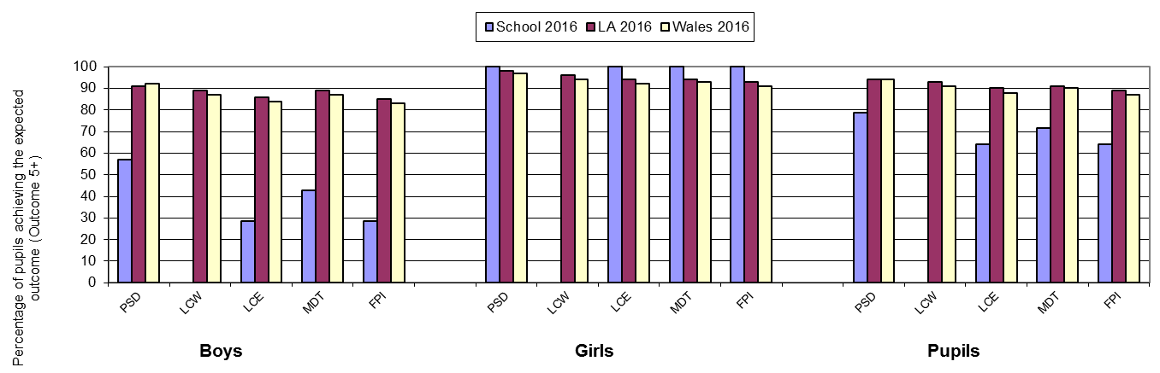

School Performance over time (2012 - 2016)
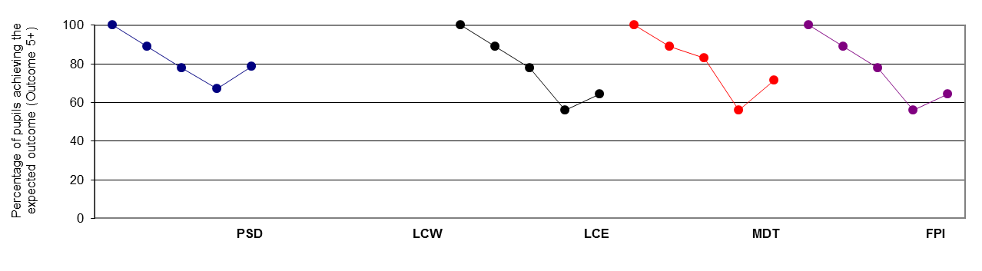

Contextual Information
Benchmarked against schools with a similar percentage of pupils eligible for free school meals.
School's results shown in greyed boxes. Column headings refer to…
Quarter 1 | School is in the top 25 per cent.
Quarter 2 | School is in the top 50 per cent but not the top 25 per cent. |  |  |  |  |  |  | Free School Meal Group
Quarter 3 | School is in the bottom 50 per cent but not the bottom 25 per cent. |  |  |  |  |  |  | More than or equal to 16 per cent and up to 24 per cent eligible for FSM
Quarter 4 | School is in the bottom 25 per cent.
 |  | Quarter 4 | Lower Quartile | Quarter 3 |  | Median | Quarter 2 | Upper Quartile |  | Quarter 1
 | PSD | 79 | 94 |  |  | 98 |  | 100
 | LCW |  | 82 |  |  | 89 |  | 97
 | LCE | 64 | 86 |  |  | 91 |  | 94
 | MDT | 71 | 87 |  |  | 92 |  | 96
 | FPI | 64 | 83 |  |  | 88 |  | 93
 | The benchmarks have been calculated using a three-year average for Free School Meal data.

School comparative information: National Curriculum Assessments 2016 with benchmarking
Key Stage 2
Percentage of boys, girls, and pupils achieving at least the expected level (Level 4+):
 | Boys |  |  |  | Girls |  |  |  | Pupils
 | School 2016 | LA 2016 | Wales 2016 |  | School 2016 | LA 2016 | Wales 2016 |  | School 2016 | LA 2016 | Wales 2016
English | 100 | 90 | 88 |  | 100 | 95 | 93 |  | 100 | 92 | 90
Welsh | 0 | 89 | 88 |  | 0 | 94 | 93 |  | 0 | 92 | 91
Maths | 100 | 90 | 89 |  | 100 | 94 | 93 |  | 100 | 92 | 91
Science | 100 | 91 | 90 |  | 100 | 95 | 94 |  | 100 | 93 | 92
CSI | 100 | 88 | 86 |  | 100 | 93 | 91 |  | 100 | 90 | 89
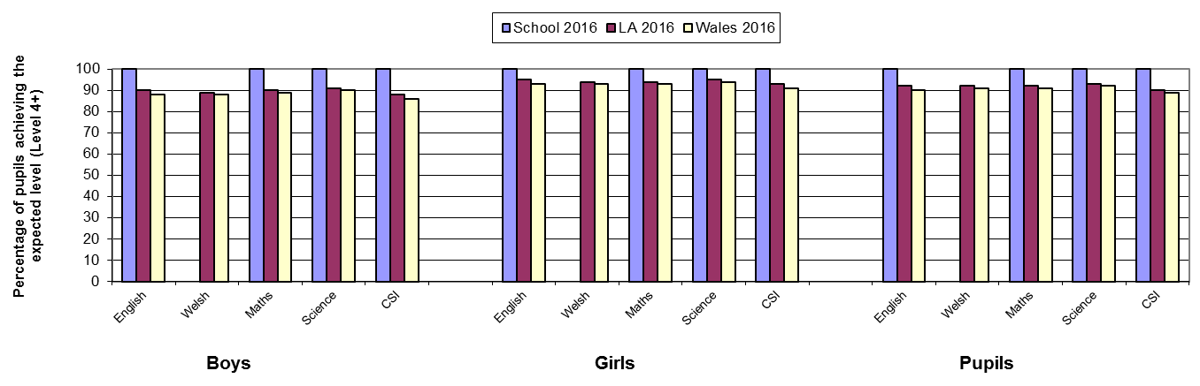

School Performance over time (2012 - 2016)
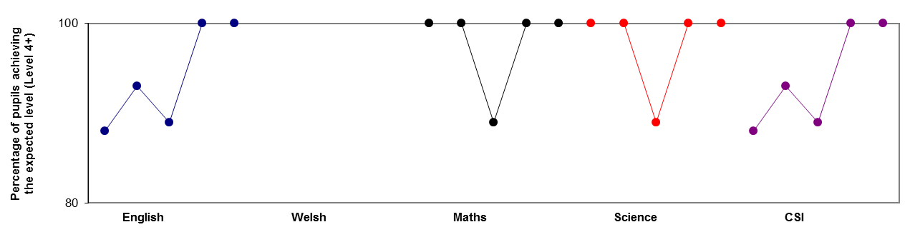

Contextual Information
Benchmarked against schools with a similar percentage of pupils eligible for free school meals.
School's results shown in greyed boxes. Column headings refer to…
Quarter 1 | School is in the top 25 per cent.
Quarter 2 | School is in the top 50 per cent but not the top 25 per cent. |  |  |  |  |  |  | Free School Meal Group
Quarter 3 | School is in the bottom 50 per cent but not the bottom 25 per cent. |  |  |  |  |  |  | More than or equal to 16 per cent and up to 24 per cent eligible for FSM
Quarter 4 | School is in the bottom 25 per cent.
 |  | Quarter 4 | Lower Quartile | Quarter 3 |  | Median | Quarter 2 | Upper Quartile |  | Quarter 1
 | English |  | 86 |  |  | 92 |  | 96 |  | 100
 | Welsh |  | 79 |  |  | 91 |  | 97
 | Maths |  | 87 |  |  | 93 |  | 99 |  | 100
 | Science |  | 87 |  |  | 94 |  | 100 |  | 100
 | CSI |  | 84 |  |  | 90 |  | 95 |  | 100
 | The benchmarks have been calculated using a three-year average for Free School Meal data.

Budget Overview for 2015-16

School Budget2015-16
Expenditure
Employees (total Staffing Cost) | £389,008
Premises Related | £32,276
Supplies and Services | £19,051
Service Level Agreements | £16,801
TOTAL EXPENDITURE | £457,257
INCOME
Income | £88,613
Net Expenditure | £368,644
Total Funding (formula allocation/Carry Over) | £415,234
Contingency/Surplus Budget | £46,590

